History Tidbits
“Eat Fresh, Eat Local”
By Johanna McBrien
Originally published in the Dedham Times, June 19, 2020

When vendors set up their stalls for the opening of a farmers market, it’s a sure sign of summer. There are differing opinions on when the first market in this country was started. It may have been in Boston in 1634; the oldest continuously operating farmers market started in Pennsylvania and dates to either the 1730s or 1752. A market can be a year-round, single establishment or gathering of vendors (which dates back to ancient Egypt), a public market with permanent stalls within a building, or a seasonal open-air farmers market.

While dry goods stores supplied household provisions, individual markets were a reliable resource for fresh vegetables, meats, and other basic foodstuffs. This changed in the early twentieth century when self-serve grocery stores were introduced, the first being the Piggly Wiggly in Memphis, Tennessee, in 1916. Grocery stores offered convenience and wider selections, with numerous goods not produced locally. The familiar farmers markets of today played an important role during WWII when fresh food was in limited quantity at grocery stores because of rationing, though interest diminished thereafter as grocery stores restocked. There was a resurgence in farmers markets in the 1970s as people became more health conscious and wanted to know where their food came from. In recent years, interest in supporting small farms, growing organic and sustainable crops, and “eating local” has contributed to the success of farmers markets.

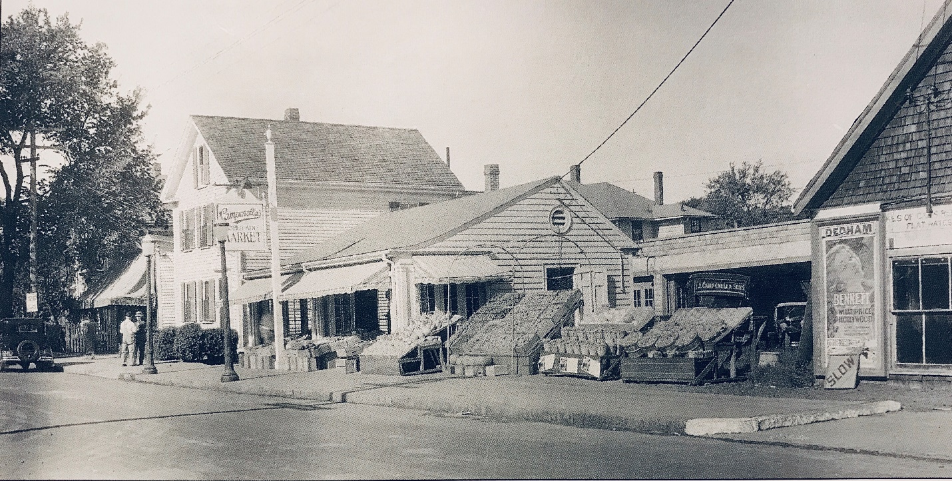

Campanella’s Open Air Market on High Street opened in June 1927.
Collection of the Dedham Historical Society & Museum.

Before refrigeration, households did their “marketing” daily, and “provision dealers” where located throughout a town. According to historian Frank Smith in his History of Dedham, Massachusetts (1936), the first market in Dedham was started in the 1850s “in the basement of the Insurance Building on High Street.” While residents acquired their food from butchers, dry goods stores, bakers, and other purveyors before then (including bartering with farmers), Campanella’s Open Air Market, located near where the Route 1 overpass is now, offered fresh fruits and vegetables on High Street starting in June 1927. While different from farmers markets, other fruit and vegetable markets in the 1930s directory, for instance, included Edgerly’s on Whiting Avenue, Hartnett’s on Mount Hope Street, Johnson’s on Myrtle Street, Karafatias’ on Washington Street, the Paspates’ on East Street, and Siikotos on Emmett Avenue.

The Dedham Farmers Market was founded in 2008 by Dedham residents Louise Reohr and Adina Astor in partnership with the Dedham Square Circle. This past Wednesday saw the start of the 13th season and the market will run every consecutive Wednesday from 2-6pm through the end of October. Says Dedham Square Circle Executive Director Amy Haelsen, “The farmers market will offer produce from local farms and locally produced and prepared foods from several specialty vendors. Despite some limitations on market operations this season due to COVID-19, we will still offer live music and the warm, welcoming vibe people have become accustomed to.” So, eat fresh, eat local, and enjoy the bounties of the summer and fall season.

Captions: Campanella’s Open Air Market on High Street opened in June 1927. Image in the collection of the Dedham Historical Society & Museum.

Caption: A Christmas display in the window of the Union Market located on High Street at Eastern Avenue. Image in the collection of the Dedham Historical Society & Museum.

Johanna McBrien is the Executive Director of the Dedham Historical Society & Museum.

See the next page for a scan of the Dedham Times article.
