History Tidbits
Dedham High School
By Johanna McBrien
Originally published in the Dedham Times, June 12, 2020
Congratulations Dedham High’s class of 2020! After their June 6th graduation, the senior class is looking forward—but let’s take a look back at the history of Dedham High School.

Dedham’s educational system began in 1644 when the town voted to establish the first free, tax-supported public school. By 1648/9, a central schoolhouse was built near the meetinghouse, both of which were located on what is now the green of the First Church and Parish (look for the bronze tablet mounted on a stone by the entrance). The one-room school measured 18 x 15 feet and students of all ages would have attended. In response to the expanding population, in 1717 the town voted to have additional schools located in various parts of town.

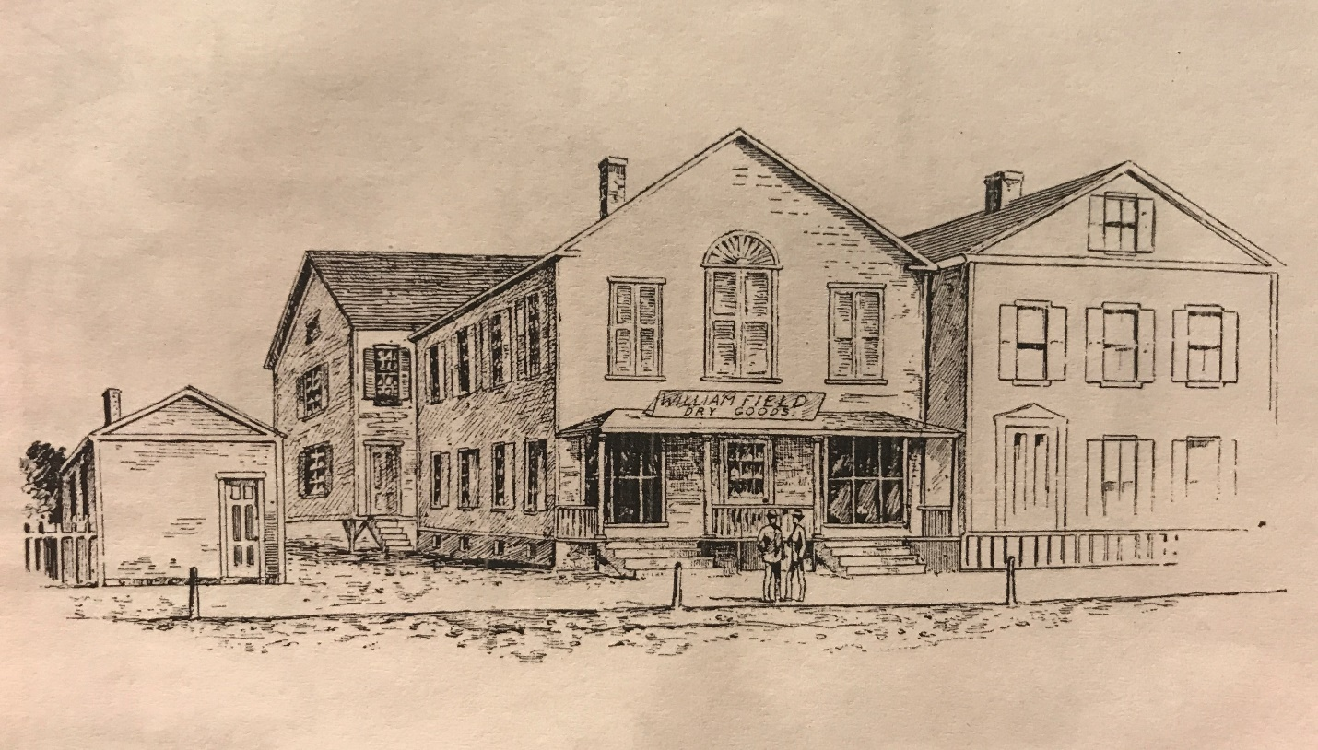

Masonic Hall, over Field’s Store, on Church Street. The second floor was later occupied by
Dedham’s first high school, from 1851-1854.

On May 12, 1851, Dedham Town Meeting voted to “hire a building and teacher, and establish a High School according to law”; this was only after Readville resident William Damrell threatened a lawsuit against the town for failing to create a high school as the Commonwealth had mandated since 1827; Dedham had been considering the decision since 1844. The high school was held above a dry goods store at the present 25 Church Street, where the new principal, Charles Capen, had taught privately since 1849. Built in 1829, the ground floor was originally occupied by Field’s Dry Goods Emporium (between ownership by two Field family members, the first floor was used as an indoor velocipede rink [bicycles and other wheeled devices]). The Masonic Lodge used the second-floor front rooms for meetings into the 1830s. Later, there was a daguerreotype studio in the front rooms and Miss Emily Hodge taught private school in the rooms at the rear. One of her students, wrote that she was “much beloved by all her pupils.”

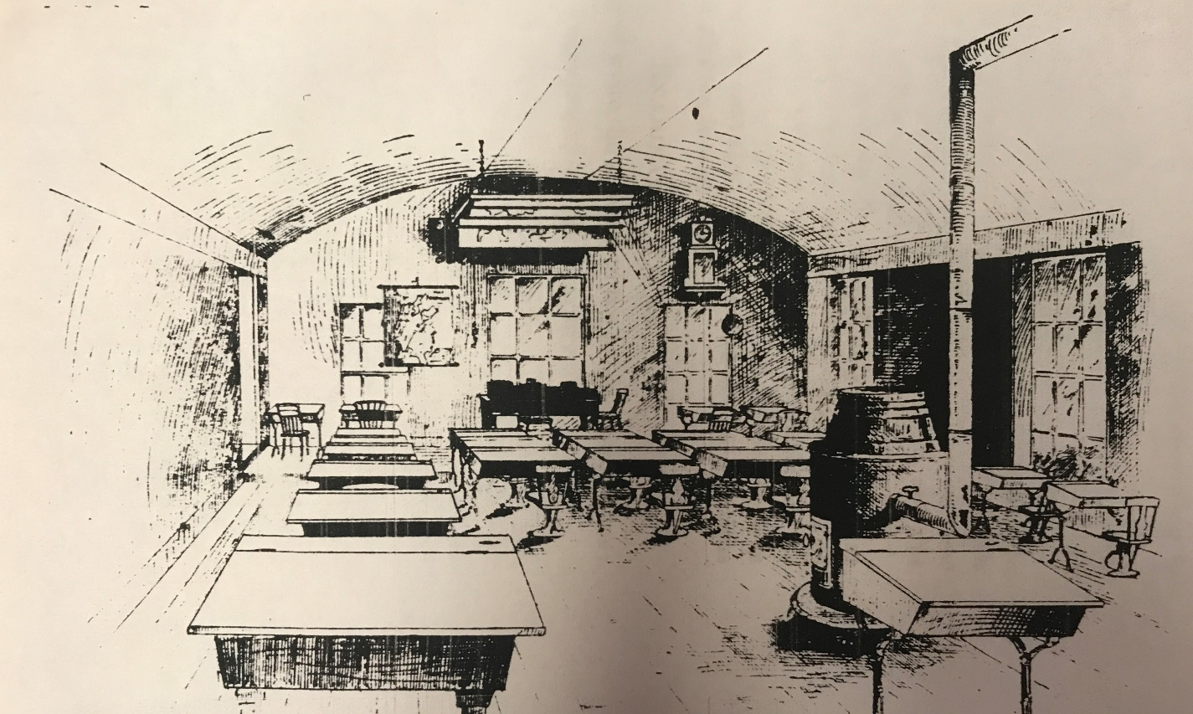

Interior, Dedham’s first high school, Church Street.

In 1851, the second floor became the first location of the Dedham High School, a public school with a student population of forty-one. Admission was only upon passing a rigorous written two-day test that included questions about American and European geography (such as “What [is the name of the] channel off Africa between the main land and the island of Madagascar?), arithmetic (If a figure in the Minuend be smaller than in the corresponding one in the Subtrahend, what is to be done?), interest (How is compound interest on any sum at six percent found?), reading, spelling, and grammar. The building was later altered to be a residence and the current façade has existed at least since the mid-19th century; a plaque on the front of the now private home commemorates the year of DHS’s founding.

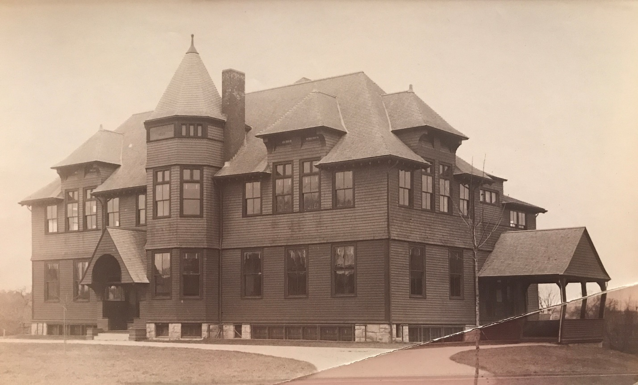

Dedham High School from 1887-1915, then the Ames Junior High School, located on Bryant Street. This wooden, two-story building measured 80 feet long and 70 feet wide. It was demolished to make way for the current town hall.
Collection of the Dedham Historical Society & Museum.

From 1854 to 1855, the high school was held at the “Town House” (town hall) on Bullard Street. A purpose-built high school was then constructed on Highland Street and used from 1855-1887, when a new high school was built on Bryant Street. This wooden building was used until 1915 when it became the Ames Junior High School; it was later torn down and in 1961 the current Town Hall was erected on the site. In the spring of 1916, the high school located at 70 Whiting Avenue was opened; Governor Calvin Coolidge (later President) took part in the dedication in 1917. The building was used as a high school until 1959 when it became the middle school (which was replaced in 2006). The “new” and current high school at 140 Whiting Avenue was built in 1959; additions and upgrades have been made since its opening.

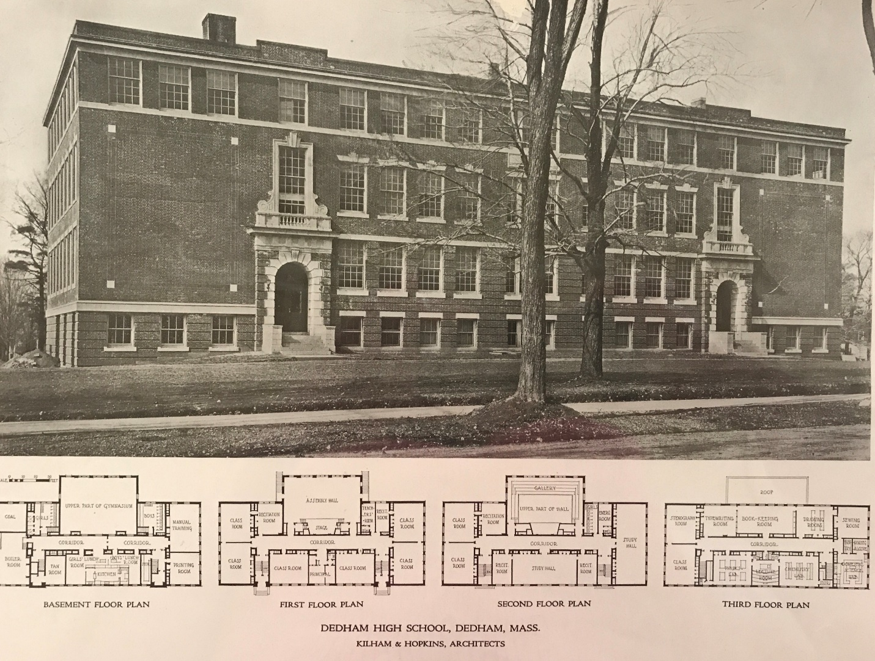

Dedham High School at 70 Whiting Avenue from 1916-1959. It was constructed of brick with granite and terra-cotta trim. It became the middle school prior to being demolished for the new middle school. Collection of the Dedham Historical Society & Museum.

The Dedham Historical Society & Museum’s archives has many records and photographs relating to the high schools, including a recollection by then Junior Class President, Jim Fiumedora, DHS class of ’74, of when he booked Aerosmith to perform at DHS; it’s quite a story. Best of luck to the class of 2020 going forward. Please send us your stories so you can also be a part of your town’s history. Email the DHSM archives at library@dedhamhistorical.org. And thank you to those on Facebook who confirmed some details about the previous high school.

Johanna McBrien is the Executive Director of the Dedham Historical Society & Museum.

See the next page for a scan of the Dedham Times article.
