History Tidbits
Dedham’s First Post Office & the Dedham Historical Society
By Johanna McBrien
Originally published in the Dedham Times, May 29, 2020
Were you aware that Dedham’s first post office was in the same location as the Historical Society & Museum, which is across the street for the current post office at 611 High Street?
For some perspective, the Fairbanks Tavern in Boston, owned by Richard Fairbanks, brother of Dedham’s Jonathan Fairbanks (builder of the 1637 Fairbanks House), was the location of the first post office in the colonies, established by the General Court of Massachusetts, in 1639. In 1673, the Governor of New York established a mail route between New York and Boston that ran through Dedham until it was diverted by the railroad in 1835 (the Post Road, which sections of Route 1 now traverse).
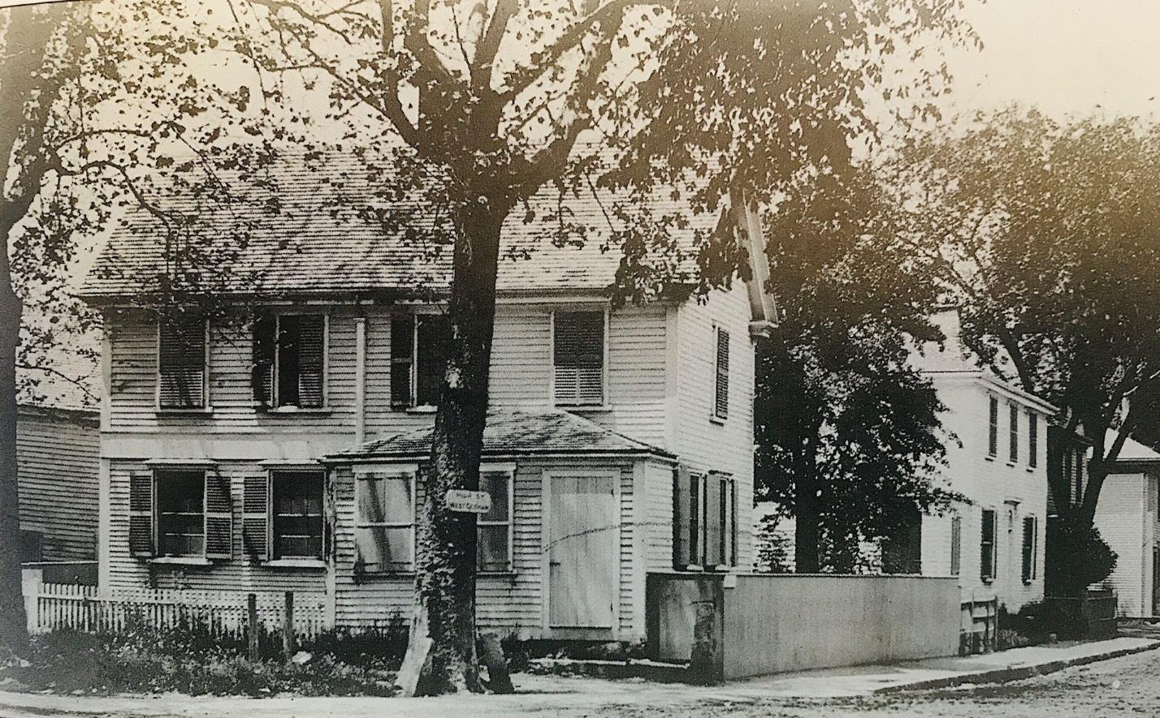
Photograph of Dedham’s first U.S. post office, the home of Jeremiah Shuttleworth and his family.
Collection of the Dedham Historical Society & Museum.

On April 1, 1795, the first post office in Dedham was established in the residence of the first postmaster, Jeremiah Shuttleworth, who received his commission from George Washington. The location is where the DHSM stands at 612 High Street. It was one of the earliest official post offices in the colonies and was located within Shuttleworth’s West India Goods Store, on the first floor of his residence. It is said that mail specifically addressed was delivered to residents, but that undelivered mail was left out on a table for people to collect. The table and a post box to hold mail for those living beyond Dedham center are in the collection of the DHSM. Residents of what are now East Dedham, Westwood, Norwood, Dover, Readville, and West Roxbury would travel to Dedham center to collect their mail. Shuttleworth held the position until 1833 when Dr. Elisha Thayer was appointed by Andrew Jackson.
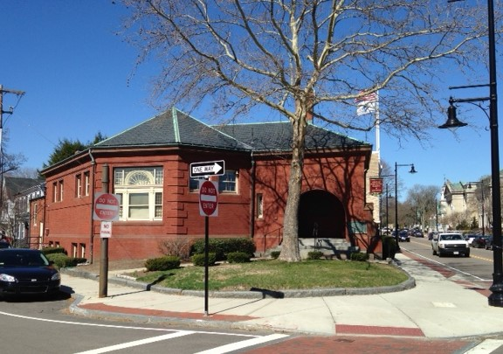
The DHSM building, built in 1888. It is the location of the museum and archives.

When Shuttleworth’s daughter, Hannah, died in 1886, she left the land to the Dedham Historical Society (est. 1859), with a bequest for $10,000 to erect a building for the organization, which had previously convened at the court house. She also left $10,000 to the library, and $30,000 to the town for the Shuttleworth Fund, which continues to provide assistance to local families in need. She requested that her home be saved and relocated, which it was in 1887. The present two-story brick structure, designed by architect Edwin J. Lewis, was opened on January 25, 1888, making it one of the oldest purpose-built historical societies in the country. Hannah’s home was moved across from the current town hall on Bryant Street; it was demolished in the 1970s.
History Tidbits is a new regular feature from the DHSM. Though the museum and archives are temporarily closed due to COVID-19, please visit www.dedhamhistorical.org for information. We invite people to join the DHSM as members or renew existing memberships. Thank you.

Johanna McBrien is Executive Director of the Dedham Historical Society & Museum.
See next page for a scan of the Dedham Times article.
