History Tidbits
Every object has a story. Play Ball!
By Johanna McBrien
Originally published in the Dedham Times, July 10, 2020

Several months ago, the Dedham Historical Society & Museum (DHSM) was given a flannel baseball jersey. It had been worn by Dedham resident John Ahearn, Dedham High School Class of 1951. Objects do not exist in isolation, so the DHSM wanted to learn about John during the time he would have worn the jersey. So, who was John Ahearn?

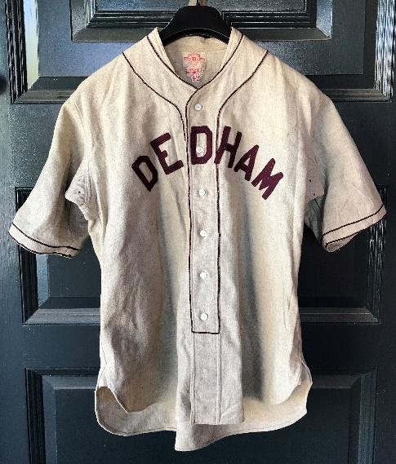
Flannel baseball jersey worn by John Ahearn, DHS Class of 1951. Collection of the DHSM (2020.01).

The bio under Ahearn’s class picture notes he was planning to enlist in the Air Corps, and was known to classmates as “Pooch.” According to the details, he was “. . . a mainstay of the baseball and hockey squads . . . his spirit and personality made him the most popular boy in the class . . . [and] his collection of ties is enough to make any girl swoon.” Ahearn was the Senior Class Vice President and the Vice President of the Student Council, which arranged what was surely a milestone, to have a juke-box in the cafeteria two days per week. As Traffic Marshall, also senior year, he helped keep order in the corridors. Additionally, Ahearn worked as a stage hand for the senior play.
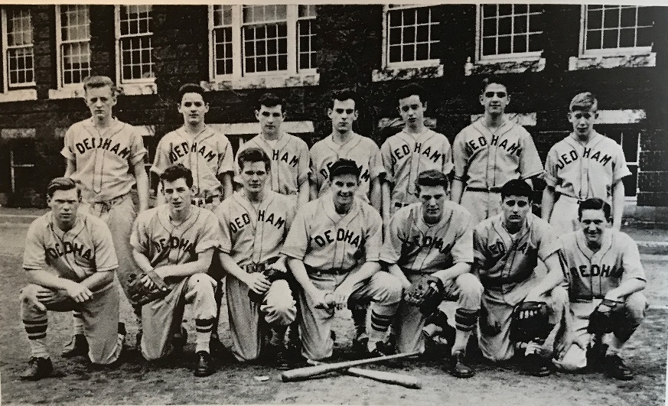
DHS 1951 baseball team. Ahearn is in the bottom row, second from the left. DHS yearbook photo.

Active in DHS sports, Ahearn wore the donated uniform during his three-year tenure on the baseball team (2nd, 3rd, 4th year), which in 1951 held fifth place in the Bay State League. The yearbook pages about the hockey team, which Ahearn was on only during his senior year, note that, “John Ahearn completed his first and last season very successfully, as he wound up high among the other top goalies. Dedham was thoroughly represented in the annual All-Star game, as Ahearn was in the goal . . .” In his ability to stop the puck, he was described as “brilliant.” Ahearn had also played J.V. Football in his first two years.

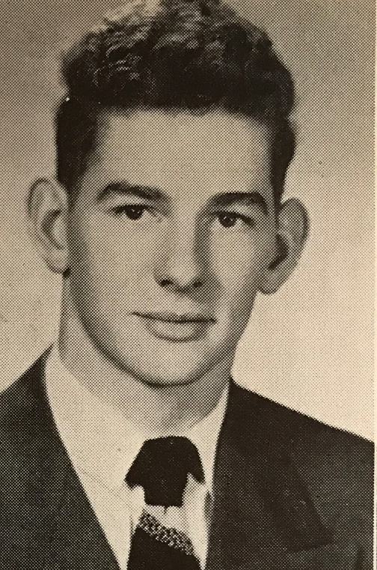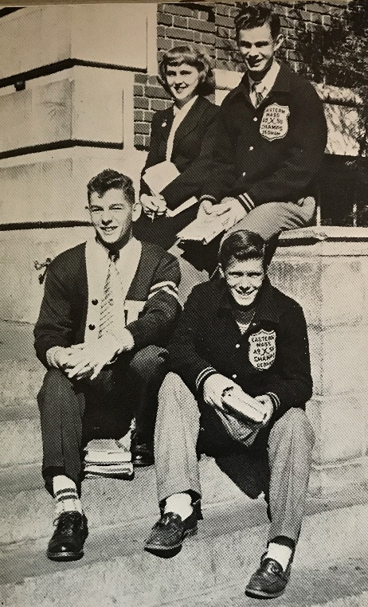

Left: John Ahearn 1951 DHS yearbook photo. The 1951 yearbook is in the collection of the DHSM.
Right: Class officers, 1951: John Ahearn, vice president; George Haskell, president; Ann Eilertson, secretary; John Haynes, treasurer. DHS yearbook photo.

To provide some perspective about Ahearn and his classmates of ‘51, in their reminiscences they described themselves as Depression Babies, born in the years 1932, 1933, 1934, when there was rarely a spare dollar; this they associated with their “hungry” attitude. World War II had begun when they entered first grade. When this class was at DHS, the hallways resounded with the phrase “George!” which had begun to succeed “Wha’ Hoppen?” Hit songs during senior year included “Tennessee Waltz,” “Be My Love,” and “Dream a Little Dream of Me” (though the class was partial to “Stardust”). Top movies included “Harvey” and “Sunset Boulevard.” Among the Class of 1951’s favorites? Comic strip: “Li’l Abner”; comedian: “Sid Cesar”; female vocalist: “Doris Day”; male vocalist: “Bing Crosby”; parking lot: “Turtle Pond”; TV program: “Your Show of Shows; and the class of 1951’s favorite school subject? History. (DHSM’s favorite answer.)

Every item has a story, and the DHSM is always interested in collecting material that tells the stories of Dedham’s residents and the town’s history, past and present. If you have material relating to Dedham that you would like to donate, please send an email about the item(s) to society@dedhamhistorical.org. While we cannot accept all material, we welcome your emails. We are particularly interested in 20th- and 21st-century military images, letters, and memorabilia.
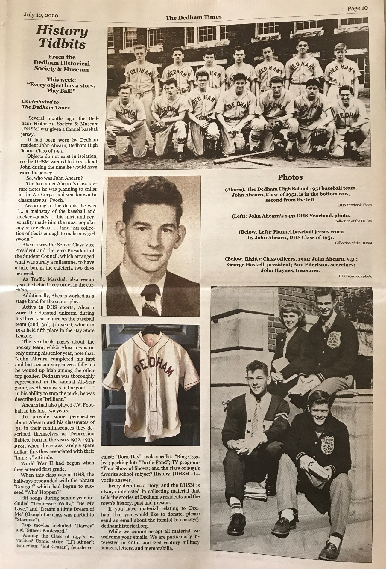

Johanna McBrien is Executive Director of the Dedham Historical Society & Museum.

