Tales from Mother Brook: Part 1 – Beginnings
By Judy Neiswander
Originally published in the Dedham Times, April 17, 2020

The Mother Brook canal is a channel nearly a mile long cut into the wilderness, a scant three years after the first settlers arrived in Dedham in 1636. In both conception and execution, this massive earth-moving project seems incredible by current standards, when laying even the smallest pipe requires at least a back-hoe. The labor needed to perform this feat came from a mere 30 families―30 men, this is, augmented by various male relatives and servants―at a time when all the other activities of settlement―felling trees, clearing fields, building houses and barns, planting crops, raising livestock―were at their most demanding.

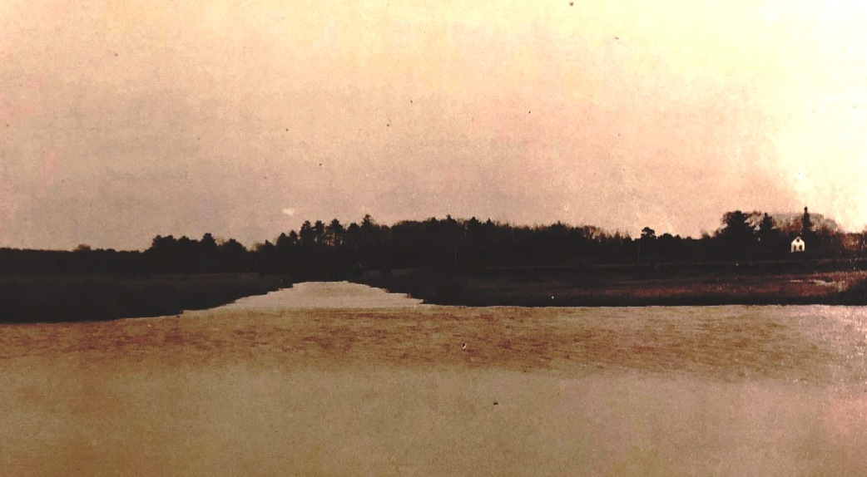
The earliest view of the canal, 1900-1936 (cropped). Collection of the Dedham Historical Society & Museum.

The urgent need was for a mill to grind grain. Initially, the town granted land to Adam Shaw, one of the original settlers, for a mill to be constructed on the Charles River near what is now Needham Street. It took every man in the town to haul the millstone from Watertown in anticipation of its completion. But Shaw died within a year with the mill still unfinished, and furthermore the Charles proved too slow moving to turn a wheel effectively. To deal with this impasse the town (then, as now) formed a committee and, as the historian Erastus Worthington described, “some fore-seeing mind conceived the idea of diverting a portion of the waters of the Charles River into East Brook...which flowed into the Neponset River.” Worthington, writing in 1900 at a comfortable distance from the actual events, added, “. . . a very little labor was required to accomplish this object.”

This “fore-seeing mind” may have belonged to one of the several original settlers who arrived from East Anglia, a low-lying and marshy area in the east of England with a long history of manipulating water levels through dykes and drainage projects. The drainage of the “Great Fens” in Cambridgeshire and Norfolk had recently been finished in the 1630s, just as the future founders of Dedham were departing from their homeland. The construction of a waterway, therefore, and the calculation of its elevation and flow, may have been a somewhat familiar project.

On March 25, 1639, the town ordered the 4000-foot ditch to be dug at public expense and levied a tax to pay for it. But even if the settlers were accustomed to undertakings of this sort, the “very little labor” that Worthington described can hardly have characterized their efforts. Every man and boy must have been involved, working together with shovels carved from wood as well as the few iron implements that they had brought with them from England. There is no record of how long construction took or of any celebration that might have accompanied the canal’s completion on July 14th, 1641. The resulting waterway, three and a half miles long from the Charles to the Neponset rivers, became known as Mother Brook from at least the 1670s and would power the manufacturing heart of Dedham for over 300 years. It is the oldest man-made canal in North America.

Judy Neiswander sits on the Dedham Historic District Commission and is a board member of the Dedham Historical Society & Museum.

