Tales from Mother Brook: Part 2 – The Five Privileges
By Judy Neiswander
Originally published in the Dedham Times, April 24, 2020

The earliest surviving map of Mother Brook dates from 1795, and has been modified in this illustration to show the sequence of privileges that were granted by the town for the establishment of mills. A “Privilege” (today we would call it a “permit”) was a serious responsibility, as it allowed a landowner to manipulate a stream with dams, sluices, and raceways to hold back and channelize the flow of water. This would have a significant impact on the amount of water available to abutters downstream.

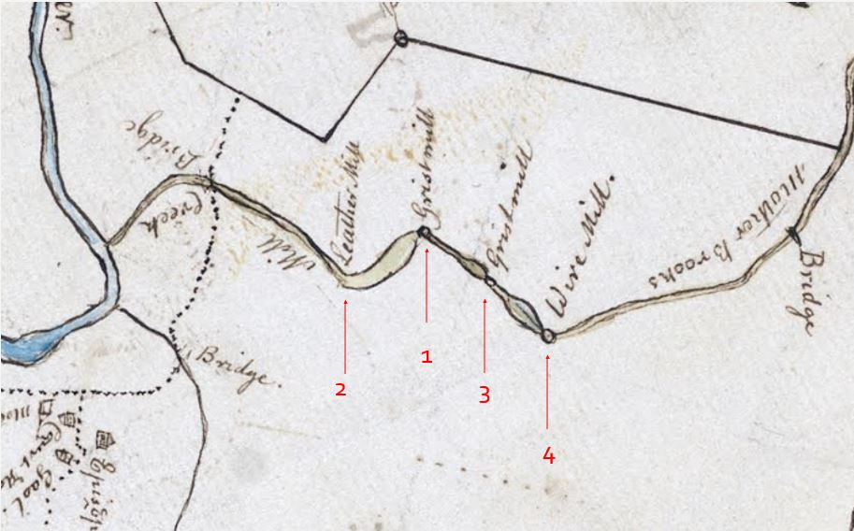
The earliest map of Mother Brook, 1795. Collection of the Dedham Historical Society & Museum.

As soon as the canal was completed in 1641, the First Privilege was granted to John Elderkin of Lynn to construct the long-desired grist mill at what is now Bussey Street, near Condon Park. Powered by a dam at approximately the same location as the current Colburn Street dam, the mill was a welcome addition to the town’s resources. In 1649 it was acquired by Nathaniel Whiting, by reputation a man with a very determined and contentious character. For five generations Whiting and his descendants (with his wife, Hannah, he had 14 children) would operate a mill at this site until the 1820s.

The Second Privilege was granted in 1664 to Ezra Morse for the construction of another grist mill to be located where High and Maverick Streets now meet, upstream from the Whiting mill. What followed was that all too familiar feature of community life everywhere―a long and acrimonious battle between entrenched neighbors. According to historian Erastus Worthington, “Mr. Whiting…complained bitterly of what he considered the injustice done to his privilege by the establishment of the mill above.” The Selectmen attempted to adjudicate the dispute by urging Whiting and Morse to “live together in a way of neighborly love.” Alas, to no avail. The two feuded over water rights for nearly 40 years until the town, fed up, removed Morse’s dam and paid him to relocate to Norwood in 1699. The following year a leather mill (tannery) was established on the site under different ownership.

In 1682 Whiting and a partner built another mill at the Third Privilege at Saw Mill Lane. This was a fulling mill, in which a wooden mechanism, operated by water power, pounded hand woven wool fabric in order to tighten and clean it, usually with the help of soap or lye. The first of many textile mills on Mother Brook, the building survived as late as 1868 when it was identified in a photograph of that date, along with the adjacent grist mill and saw mill. The Third Privilege also remained in the Whiting family for almost two centuries.

The Fourth Privilege, at present day Stone Mill Drive, was not developed until 1787 when members of the Whiting family built a factory there to produce copper pennies. This was followed by a paper mill around 1790 and subsequently a mill that produced wire. The Fifth and final Privilege was located in the Readville neighborhood of Hyde Park at the corner of Knight and River Streets. Here the stream was not dammed until the beginning of the 19th century, when the mechanization and explosive growth of the textile industry would transform the character of Mother Brook forever.

Judy Neiswander sits on the Dedham Historic District Commission and is a board member of the Dedham Historical Society & Museum.

