Tales from Mother Brook: Part 4 – The Industrial Age
By Judy Neiswander
Originally published in the Dedham Times, May 8, 2020

Once the textile industry was established, the story of the mills of Mother Brook was one of expansion, elaboration, and consolidation. Investors from outside of Dedham came and went and mills changed hands frequently over the next century or so. As the economy fluctuated, they often closed down completely and laid off all their workers, only to reopen a year or so later under a different name. What didn’t change was the overwhelming impact the mills made on Dedham.

The Dedham mills played a small but representative role in the exponential growth of textile production in 19th-century New England. Following the death of Benjamin Bussey in 1842 his mills and property in Dedham were sold to John Wiley Edmands, an associate of Amos Lawrence, one of the tight-knit group known as the Boston Associates, men from prominent Boston families who established the mill towns of Lowell and Lawrence and ruled the textile industry with an iron hand. With his partner, Gardner Colby, Edmands expanded and re-named the operation The Maverick Woolen Mills, while constructing multiple boarding houses and tenements to house company workers. The expanded workforce doubled the population of Dedham from 3,057 in 1830 to 7,198 in 1865.

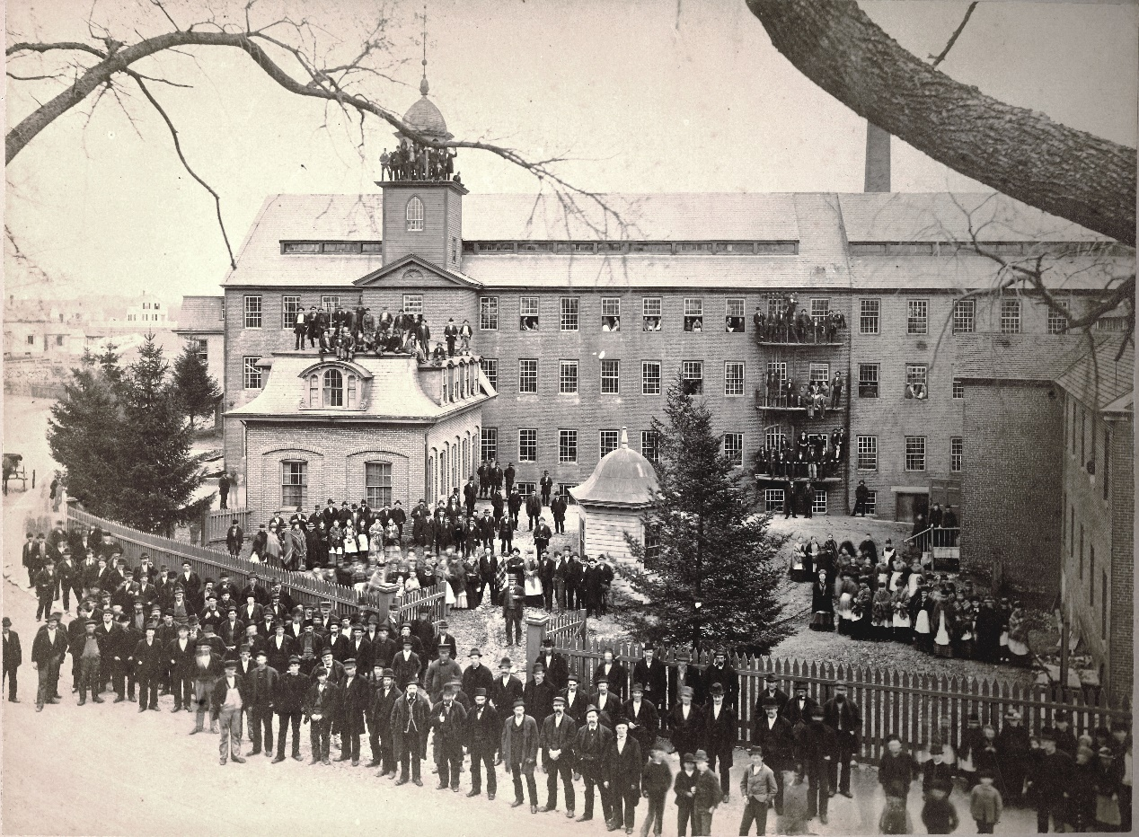
The Merchants Woolen Company Mill, around 1880. Collection of the Dedham Historical Society and Museum.

Colby, afterwards the president of the Wisconsin Railroad, re-organized the company into the Merchants Woolen Company in 1863, taking on a new partner, Edgar Harding, who also owned two mills in New Bedford. A biographical sketch of the period described Harding’s lofty milieu: “Their winter home was in Boston and their summer residence a beautiful estate at Woods Hole, Massachusetts, overlooking the ocean and harbor, where Mr. Harding occupies his vacation days in his favorite sport of yachting….his winter social intercourses, outside his own family circle, was in association with other members of the Algonquin and Union clubs of Boston.”

By 1870, Merchants Woolen Mill had become the single largest taxpayer in Dedham. Within the Maverick-Colburn area their properties included two tenements on High Street, five on Maverick, ten on Curve and two on Bussey and two “long houses” that still stand at 235 and 243 Colburn Street. All of these were rented to employees of the firm. An 1876 map shows that the Merchants Woolen Company owned virtually all the land in the triangular plot delineated by Maverick, Colburn and Curve Streets.

For men such as Edmands, Colby and Harding, the mills in Dedham were only footnote in their extensive financial portfolios. For their workers, however, the demanding schedule of the mill bell controlled their lives, and the contrast in their conditions could not have been greater. Although no specific information about conditions inside the Dedham mills has at yet come to light, there is no reason to believe they were any different from those pertaining throughout New England.

Mill owners colluded to set identical hours and wages to prevent workers from leaving to go elsewhere. Hours were long: workers were required to stand at their stations, without speaking, from 5 am until 7 pm with half an hour for lunch. They worked six days a week and their time was strictly controlled by bells and punch clocks. Known as the “Waltham-Lowell System,” the regimen had been developed by the Boston Associates at their mills in those cities and were widely adopted across New England.

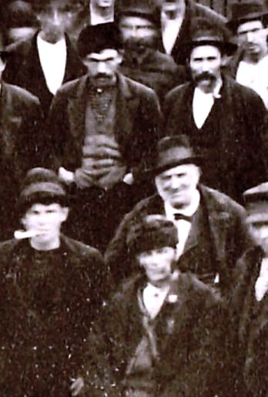
Workers at The Merchants Woolen Mill, detail. Collection of the Dedham Historical Society & Museum.

Inside the mills doors and windows were kept closed since fibers could be easily disturbed by incoming breezes, and mills were often unbearably hot and humid in the summer. In the winter, workers often shivered in the cold. The air was also thick with cotton or wool fibers; many workers got black lung as a result, as well as pneumonia, tuberculosis, and other respiratory diseases. Fire was a constant problem for the lint-filled air was explosively flammable; fire escapes were non-existent.

As the industry became more competitive the mills were squeezed to produce more profits. Machinery was speeded up and accidents were frequent as workers’ hands and fingers were maimed or severed when caught in the gears. The noise of the machines was deafening. Regulations to protect worker safety were unknown.

Men's wages were more than twice as high as women's – children made least of all but were widely employed because their small hands could reach more easily between rows of operating machinery. Where company-owned housing was provided, workers were required to live in surroundings that were often overcrowded, unventilated and squalid. The money paid in rent was returned to employers who paid wages that were barely above basic subsistence.

Such conditions were enforced by the owners’ agents who lived near the mills and supervised day to day operations. In Dedham the most effective agent was Thomas Barrows, the son of a farmer in Middleboro, who began working for Benjamin Bussey in 1825. As the mills became increasingly profitable, he prospered and became a mill owner himself when he purchased the Norfolk Cotton Mill on Milton Street in 1863. He transformed it into a woolen mill, replaced the water wheel with turbines and a steam engine, and added a large three-story granite ell to the northeast. In 1872 he sold the mill to his old employer, the Merchants Woolen Company, which by that time operated the mills at all four of the Dedham privileges. Burrows’ grand mansion on High Street, now the location of St. Mary’s parking lot, was virtually across the street from the crowded tenements of the workers he controlled and directed.
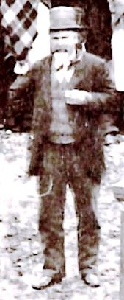
The Overseer of The Merchants Woolen Mill - Thomas Barrow?
Collection of the Dedham Historical Society & Museum.

Who were the workers who labored in East Dedham’s mills, creating vast wealth for distant investors and making little for themselves? As conditions within the mills deteriorated, the Yankee farm girls who had flocked to the early mills now avoided them. In turn, they were replaced by wave upon wave of immigrants who would enrich and diversify the population of Dedham in ways that are still evident today.

Judy Neiswander sits on the Dedham Historic District Commission and is a board member of the Dedham Historical Society & Museum.

